* Create a table in GitHub markdown based on OSI (level – protocols examples - unit).

https://gist.github.com/DmitryYankov/91477cadb28dab5ade29df6012d503b0

* Create a markdown document describing difference of the IP package in TCP and UDP L4 protocols.

https://gist.github.com/DmitryYankov/fc6d45ea5faa756062b081c900d76867

* Install OpenVPN server to one VM

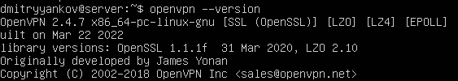

* Configure client on the second VM and connect it to the server
* Configure the server to provide Internet access to the Clients via this server only
* Markdown documents in the GitHub
* Screenshots proofing that the Client is configured to connect Internet ONLY via the server (with established VPN connection)



